APIRestful- ENPOINTS TESTING AND DOCUMENTATION

MovieController – Restful APIs

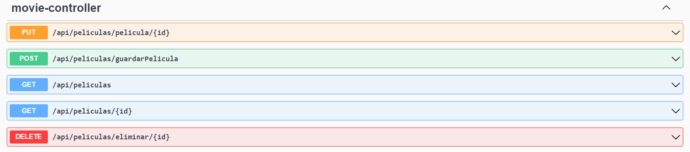

Post a movie

Get Movies

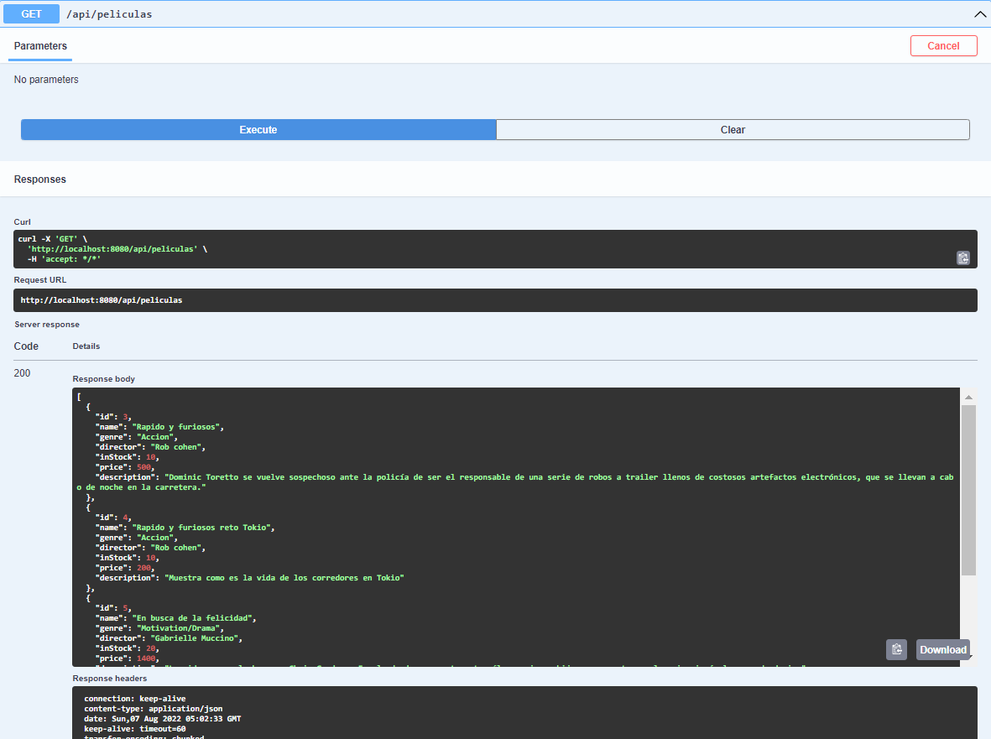

Delete a movie

Get a movie by ID, consulting.

Update a movie

UserController – Restful APIs

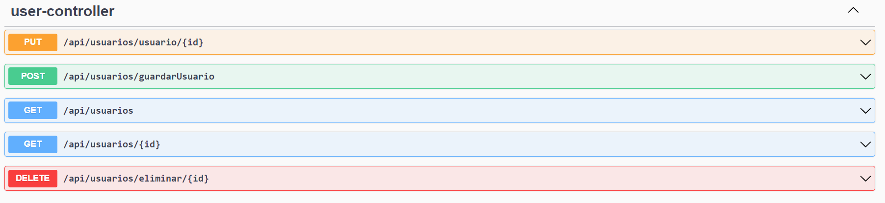

Post a User

Get Users

Delete a movie

Get a movie by ID, consulting.

Update a user – following page.

